**CN LAB 03**

**SUBMITTED BY: AYESHA ZIA(20K-0414)**

**QUESTION 01**

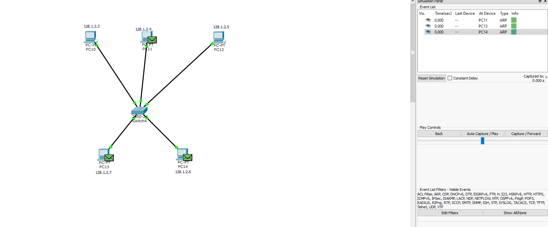

**QUESTION 02/03**

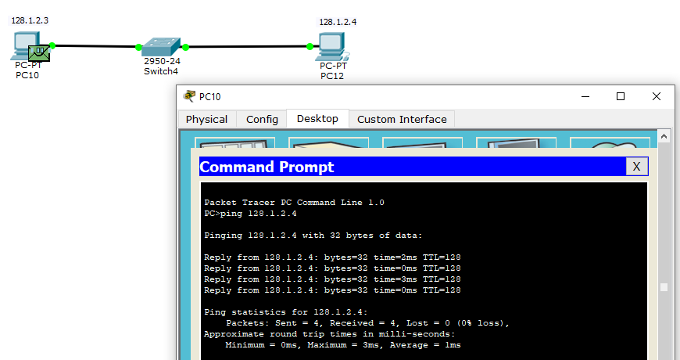

**Reason:** A straight through wire has been used as it is used to connect two different type of devices like it can be used to: Connect a computer to a switch, connect a computer to a cable, connect a router's WAN port to a cable etc.

**QUESTION 04**

The main three command modes are:

* Global configuration mode
* Interface configuration mode
* Subinterface configuration mode

**QUESTION 05**

**Pinging from PC0 TO PC1**

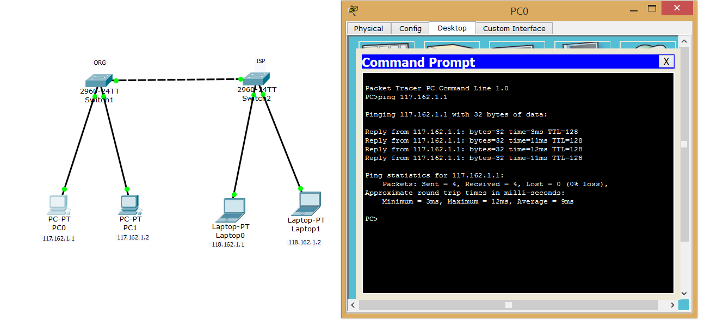

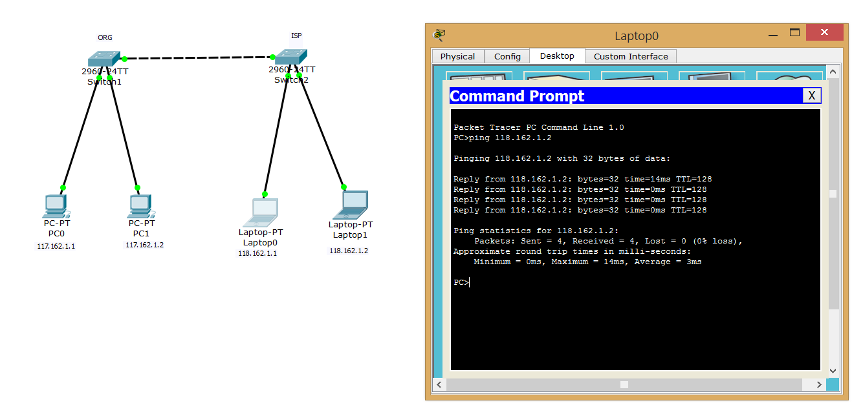**Pinging from PT0 TO PT1**

**Functionality of devices:**

The PCs and Laptops (PC0,PC1,LAPTOP0,LAPTOP1) work as end devices while the switches work as packet switches that allow the exchange of packets/data between the devices.